Neurofeedback Meta-Analysis Report 6/6/24

Miguel Velasquez

2024-06-05

Errata:

There were a few errors in the previous analysis:

- Excel was originally exporting the data with only 2 decimal places. This had resulted in some loss

of data.

- Some papers were listed as having instructions to “decrease” activity when it was actually

“increase” and vice-versa. This affected the direction of the effect sizes. I checked all the papers to make sure that the data was correct across all studies.

The pooled effect sizes were updated to reflect these changes. The changes had a small impact on the pooled effect of last vs first training session (from (*g* = .337, *p* < 0.001) to (*g* = .336, *p* < 0.001)) and had a larger impact on the post-training vs. pre-training baseline effect size (from (*g* = .2, *p* = 0.056) to (*g* = .26, *p* = 0.03))

Effect size of Transfer Trials

There was a significant effect from the first training session to transfer trial (t = 3.00, p = .03).

There was no significant effect from baseline to transfer trial (t = -.41, p = .7)

Multi-session data analysis:

In order to analyze the multi-session data 2 variables were computed: Amount of time since first training trial (or baseline) and amount of training since first training trial (or baseline).

Since observations are not independent because there are correlations within each study, a three-level mixed effects model was used which takes into account correlations within clusters (studies in this case).

The two variables that were created are skewed so I am also reporting the analyses after log transforming those variables.

Interactions

I calculated the interaction separately because I am not sure if they are valid since the two variables are correlated.

For effect size from first training trial there was a main effect of amount of training (t = 2.31, p = 0.021), a main effect of time since first training trial (t = -2.13, p = 0.035) and significant interaction (t = 2.73, p = 0.0071).

For effect size from baseline there were no significant main effects or interactions.

Egger’s test showed that there was significant evidence of publication bias (t = 2.79 p = 0.007).

I am not sure if we should pull of the studies since the effect sizes have different origins and some papers have more than one effect size. If we pool studies I don’t think we should report the funnel plot since it makes use of the averaged pooled effect size which in this case is not useful. Otherwise, the Egger’s test does not use the pooled effect.

Quality Assessments

I plotted the overall ratings of the quality assessment. According to the guidelines we are required to revise the studies with low ratings and determine if they posed significant risk of bias and should be excluded. We do not believe any of the final papers posed significant risk of bias. I believe most of these papers were already exclude through the selection process.

Next Steps

* Select subgroups that we want to do analyses on.
  + I counted the number of cases per level of each variable and if we exclude all the variables with fewer than 5 cases per level, there’s only enough data for the following variables:
    - Effect size from First trial: Blinding, instruction, rehearsal, direction, feedback, training duration; EEG only: frequency bands (alpha and SMR only), ratio use, number of channels
    - Effect size from Baseline: blinding, frequency bands, feedback, training duration

# Pooled effect sizes

Overall effect sizes showed that there was a significant effect of neurofeedback on brain signals when looking at change from first to last training sessions, baseline to post-training rest and first training session to transfer trial. There was no significant effect when looking at the change from baseline to transfer trial.

## Last vs. First training session

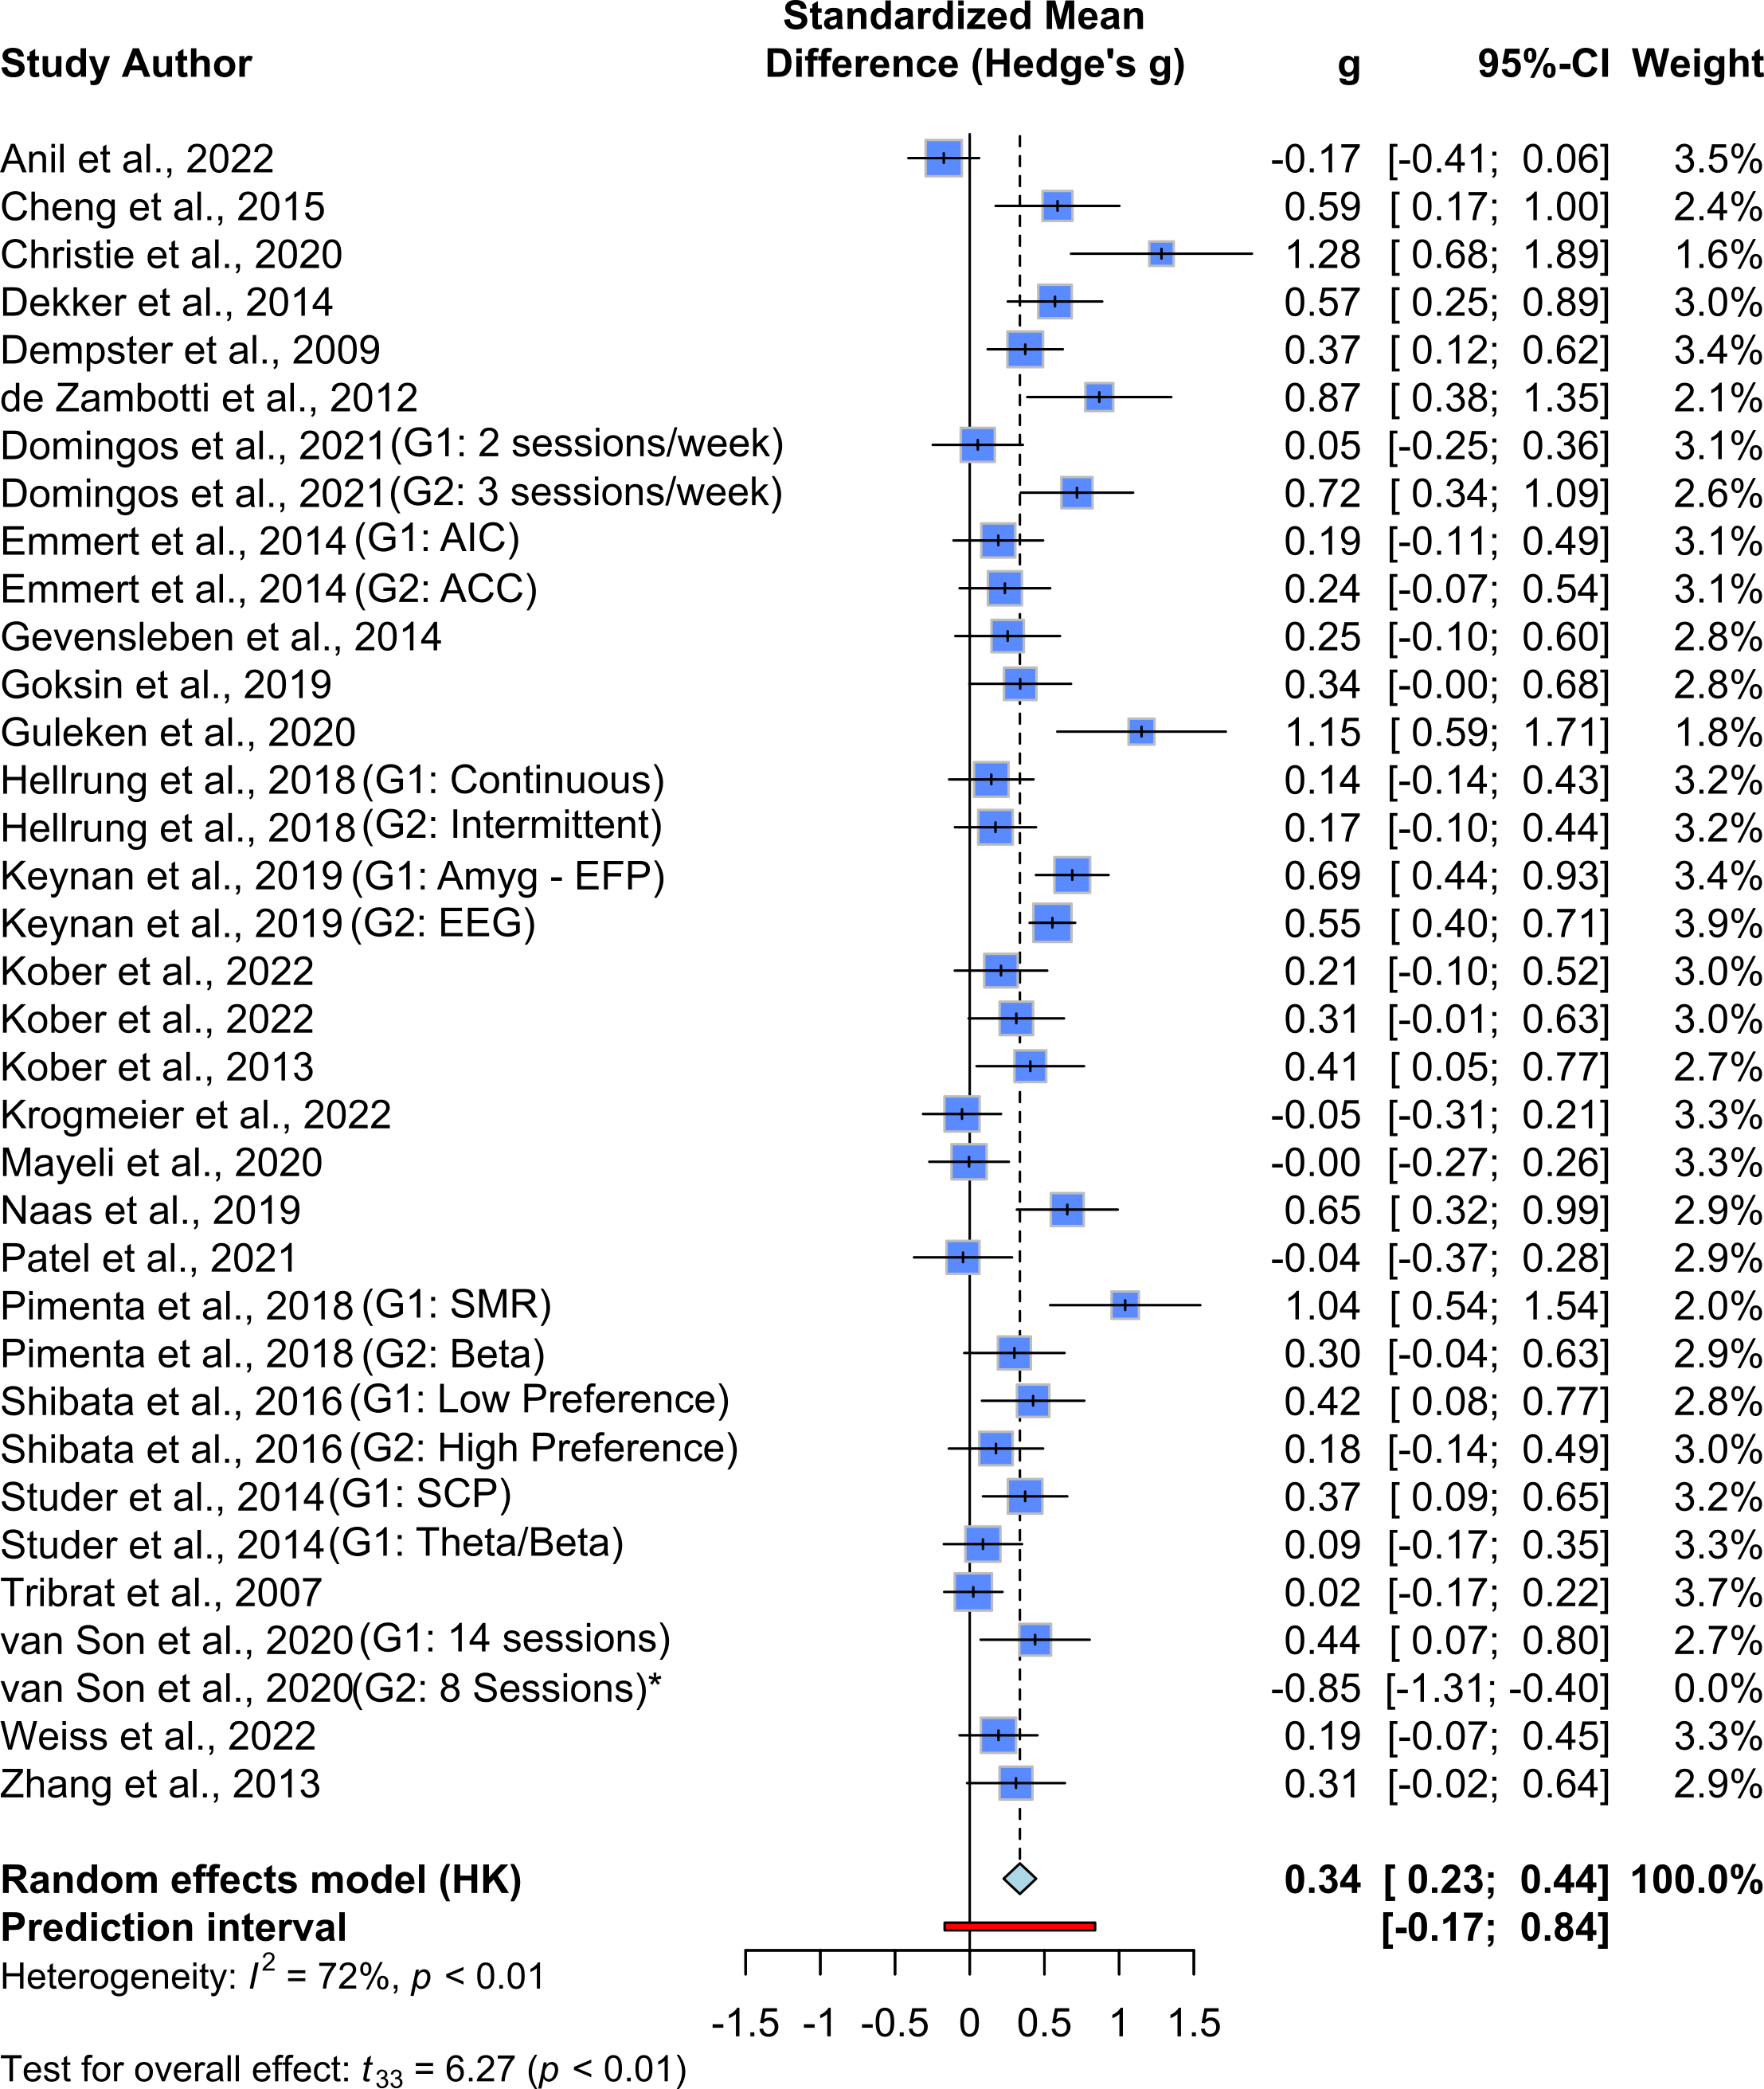

## 

## Post-training vs. Pre-training Baseline

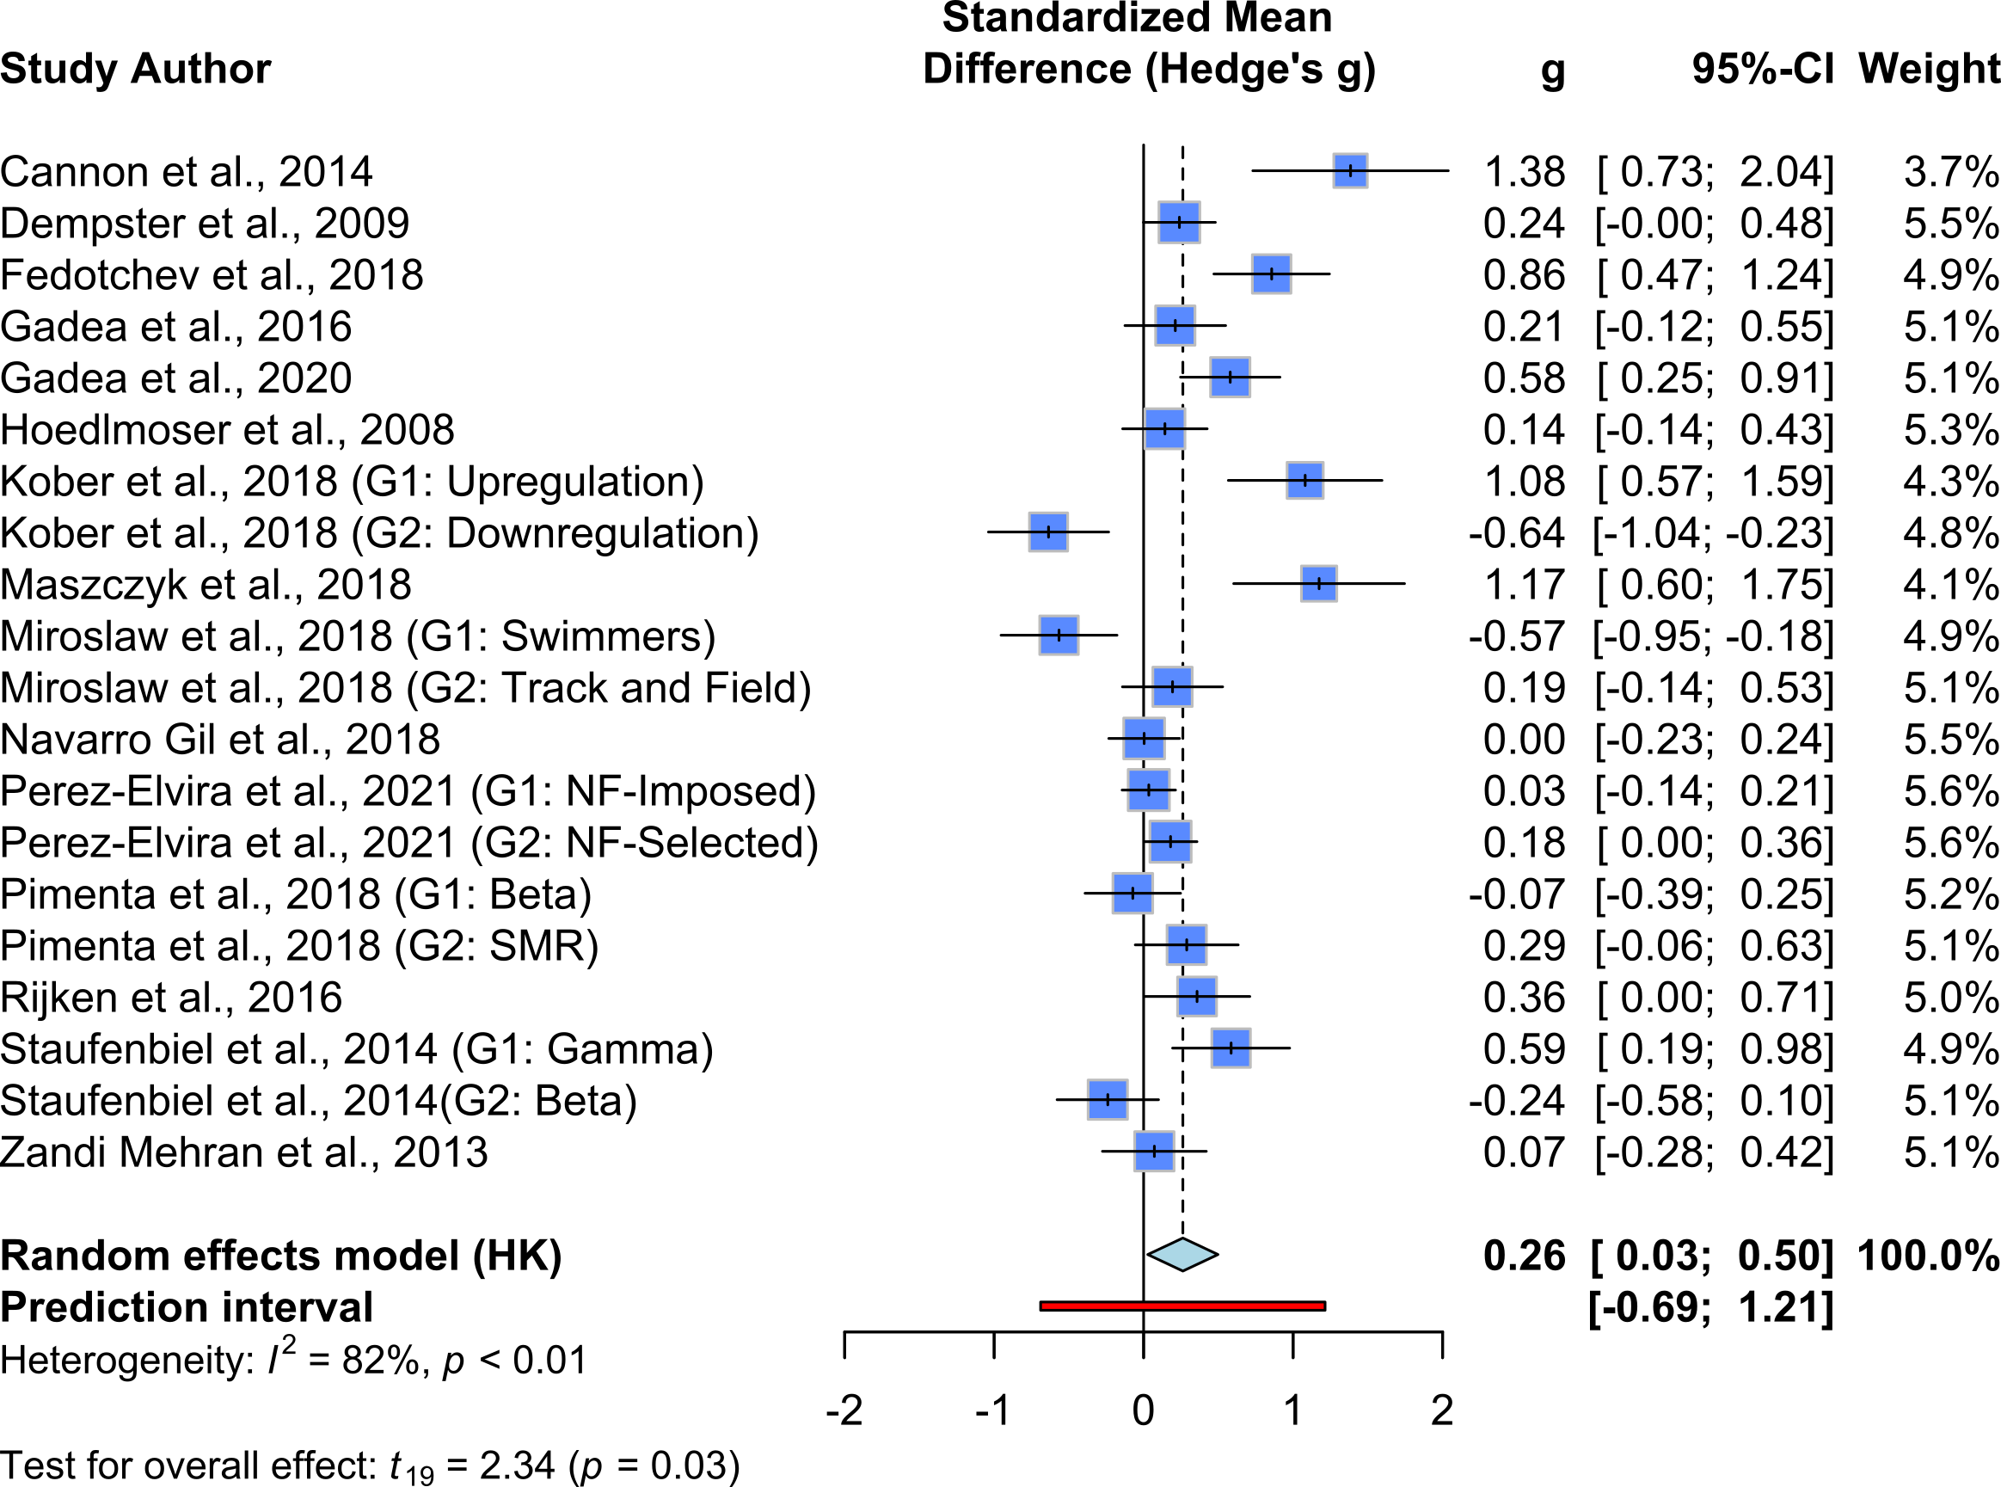

## Transfer Trial vs First Training

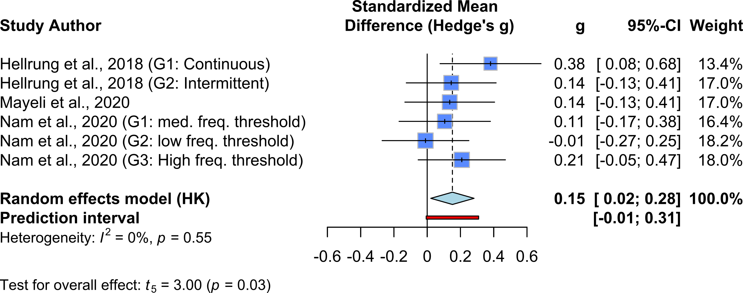

## Transfer Trial vs Baseline

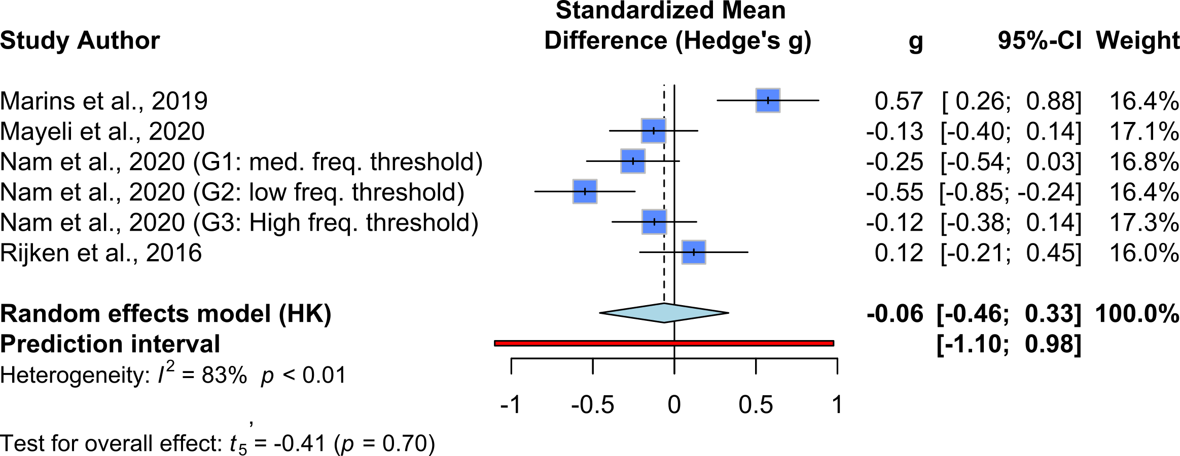

# Meta Regression for Multiple Trials

## SMD since First training session

There was a significant relationship between both amount of training and time and SMD since first training trial. Effects persisted after including the interaction term and there was a significant interaction as well.

### Amount of Training since First Training Session

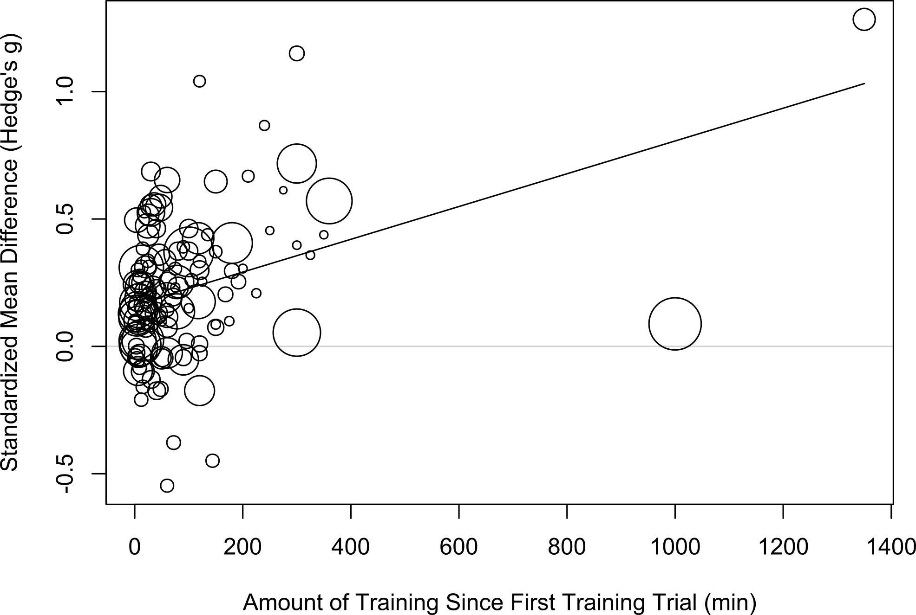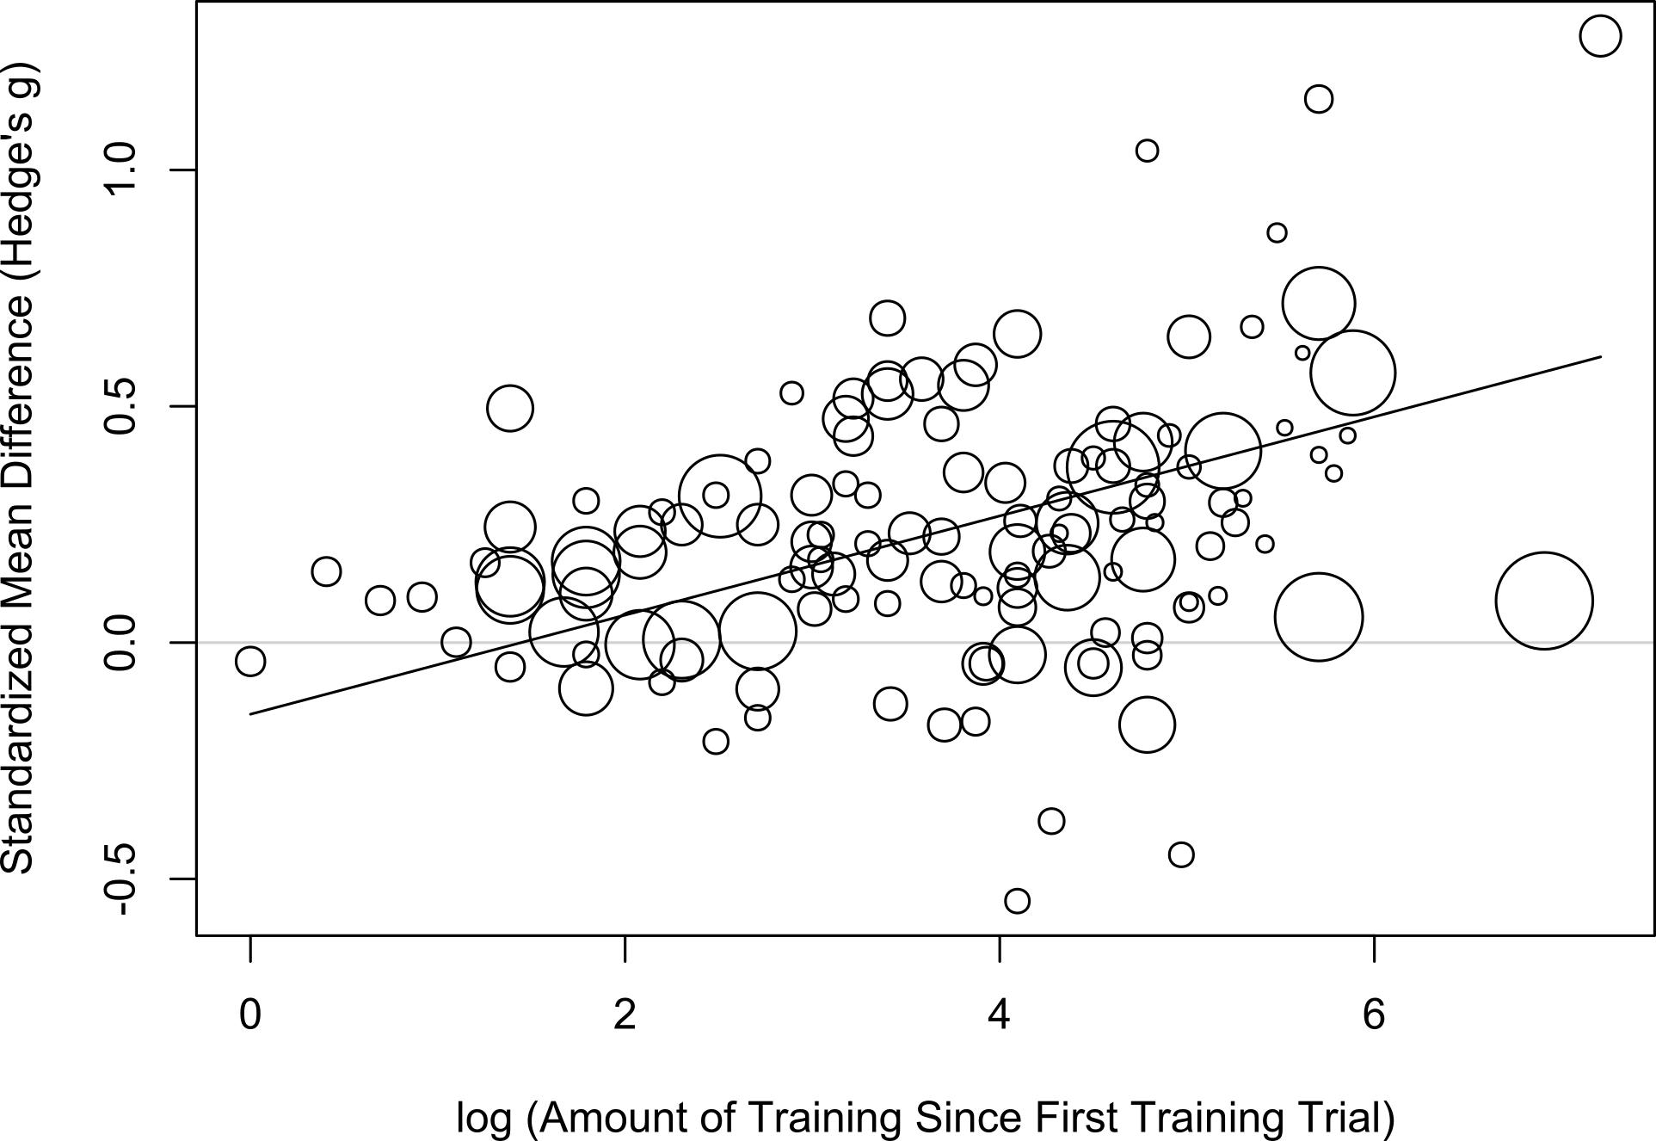

t = 3.86, p = .0002 t =4.9, p <0.0001

### Amount of Time since First Training Session

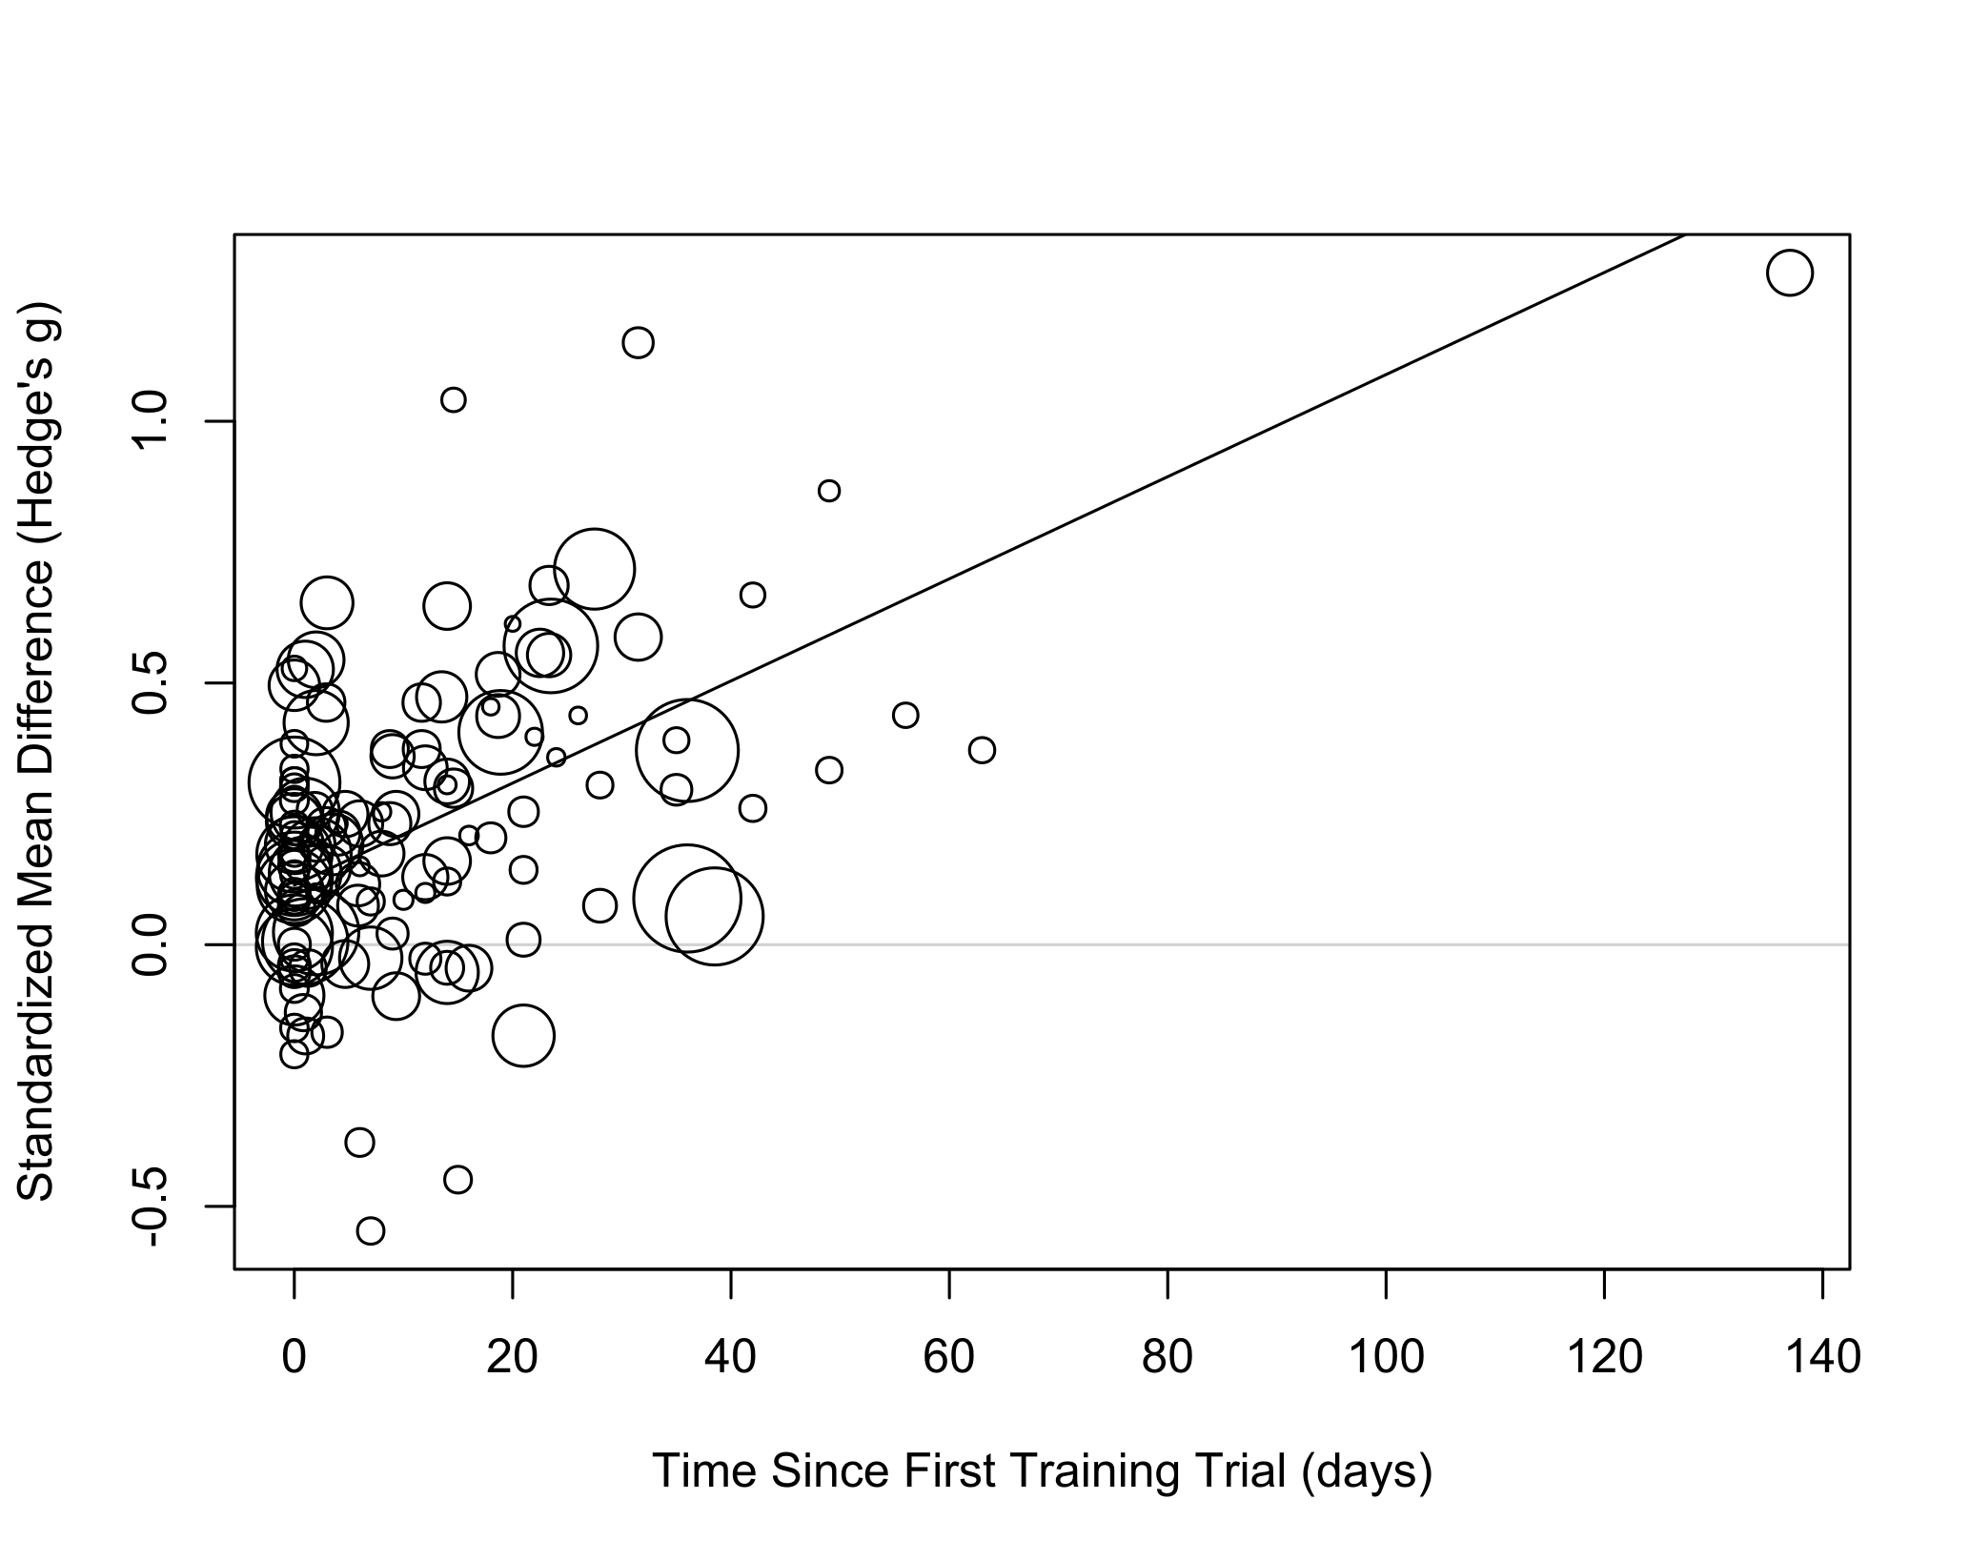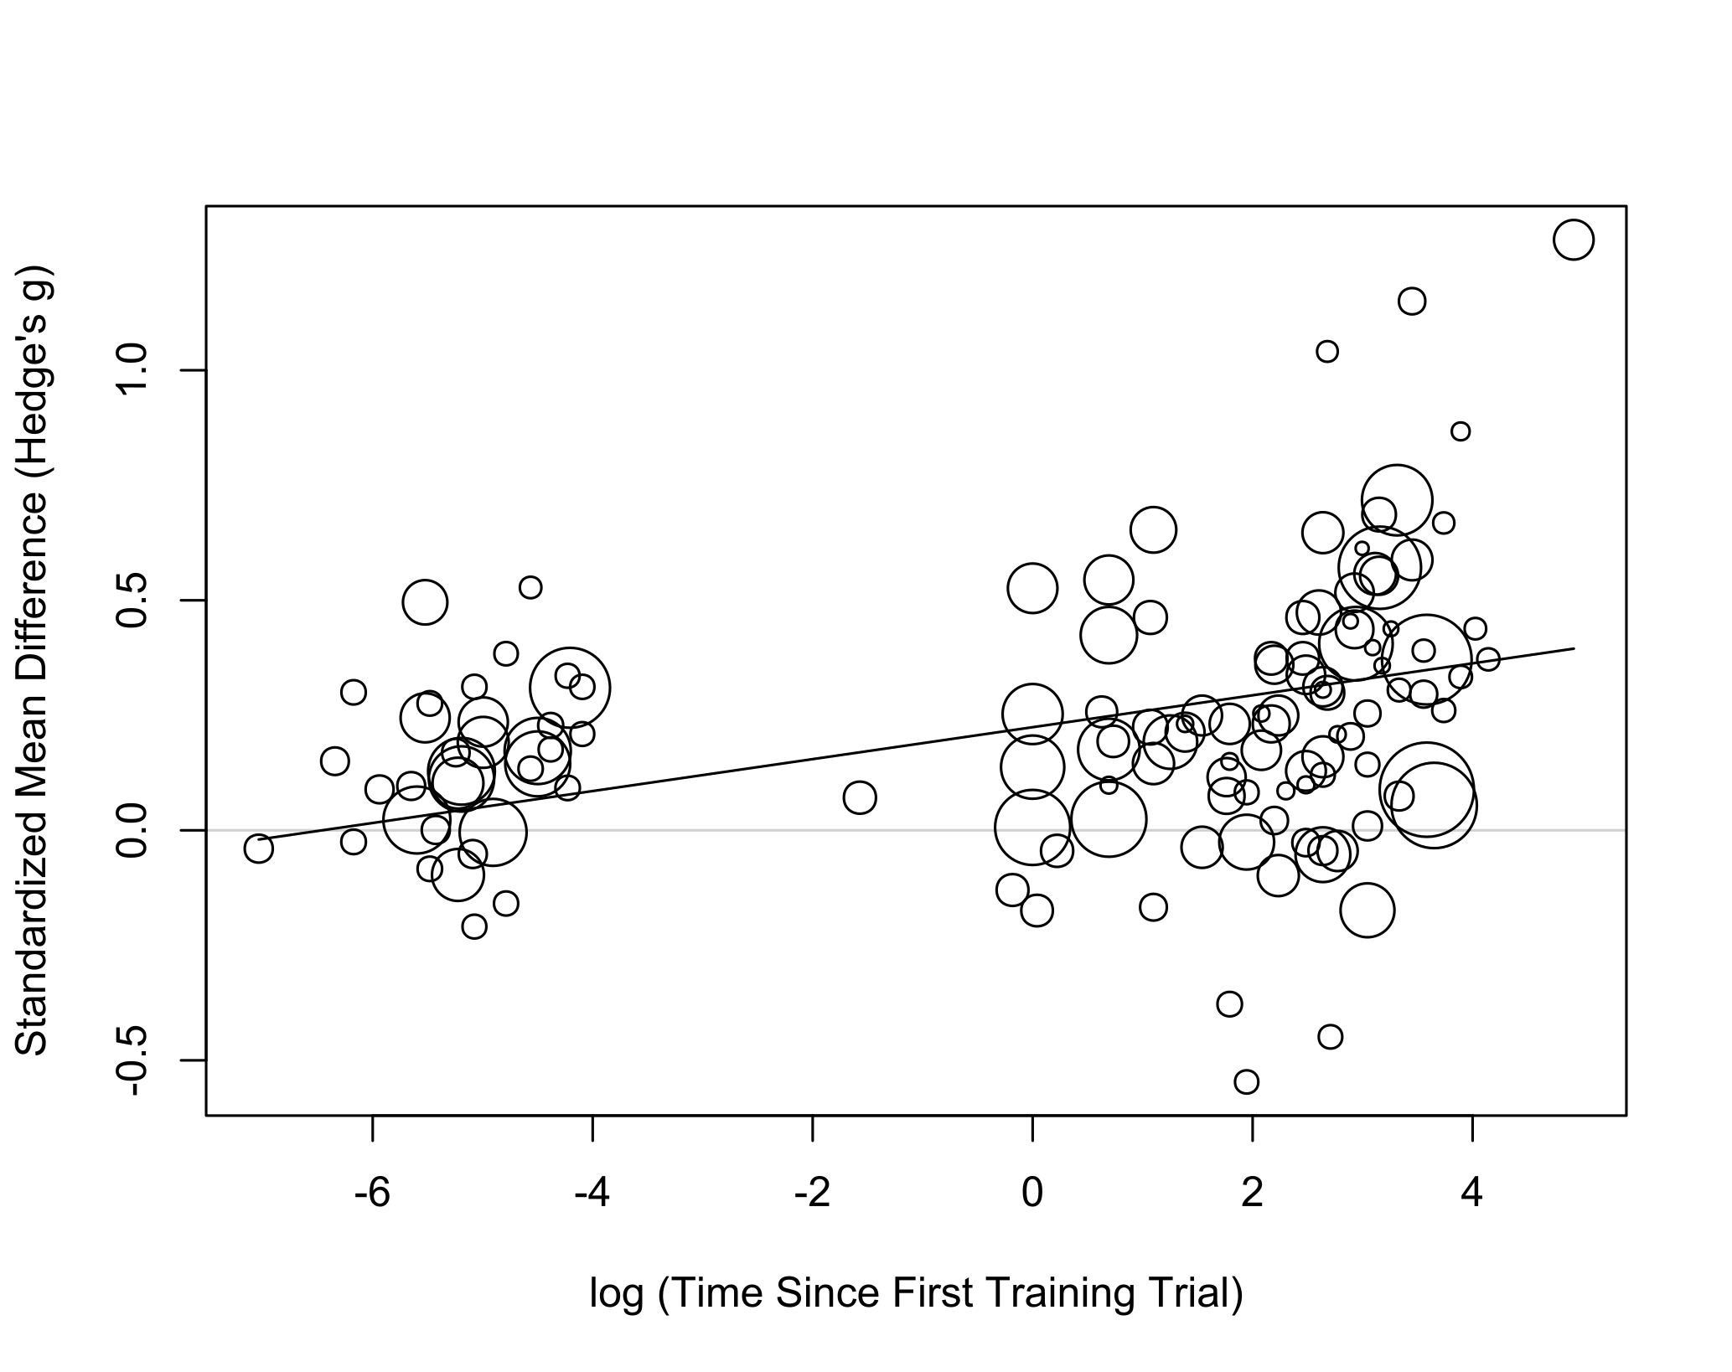

t = 6.67, p < .0001 t =3.61, p <0.0004

## Interaction Between Amount of time and training since the first training trial

## Model Results:  
##   
## estimate se tval df pval   
## intrcpt -0.2186 0.1570 -1.3920 127 .166  
## log.train_amount_since_first 0.1029 0.0439 2.3439 127 .021*  
## log.time_since_first -0.0520 0.0244 -2.1321 127 .035*  
## time X amount of training 0.0173 0.0063 2.7373 127 .0071**

## SMD since Pre-training Baseline

There was a significant relationship between both amount of training and time and SMD since baseline. However, effects disappeared when including the interaction term.

### Amount of Training since Baseline

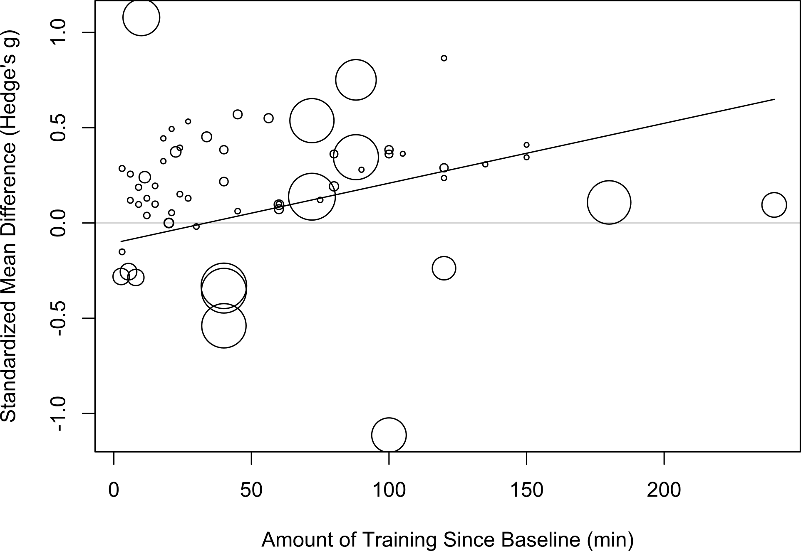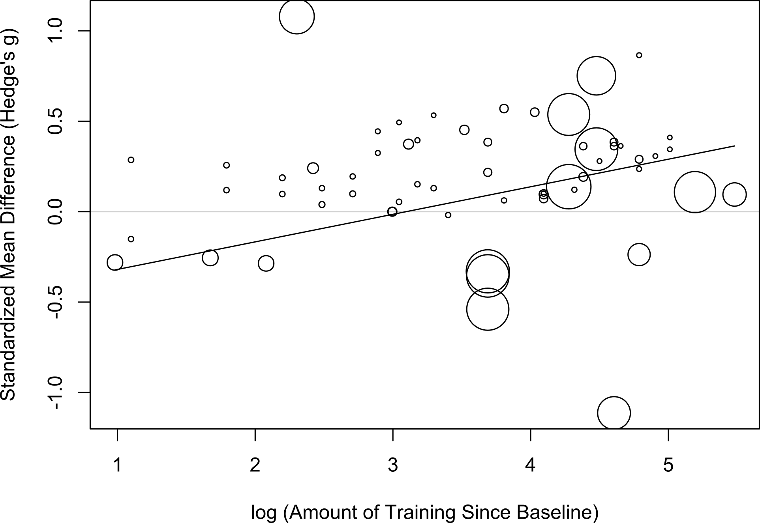

t = 4.62, p < .0001 t =4.45, p <0.0001

### Amount of Time since Baseline

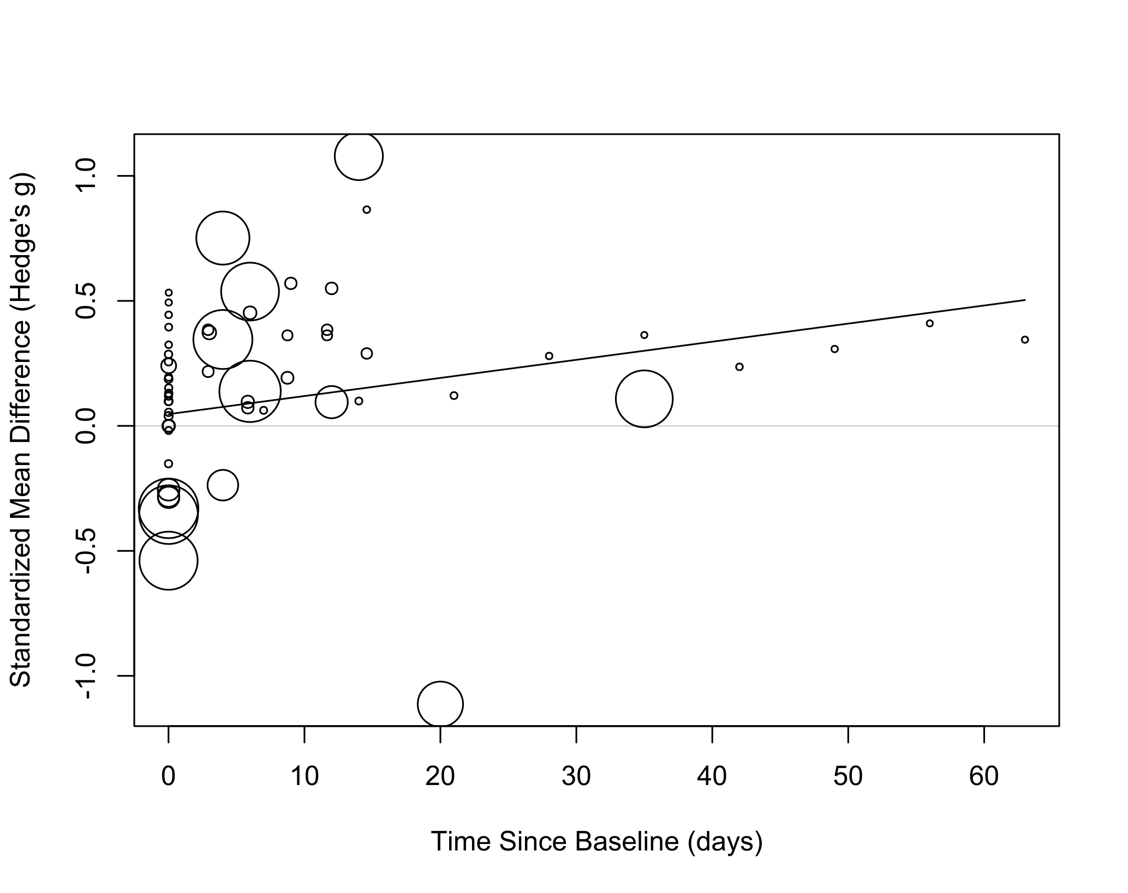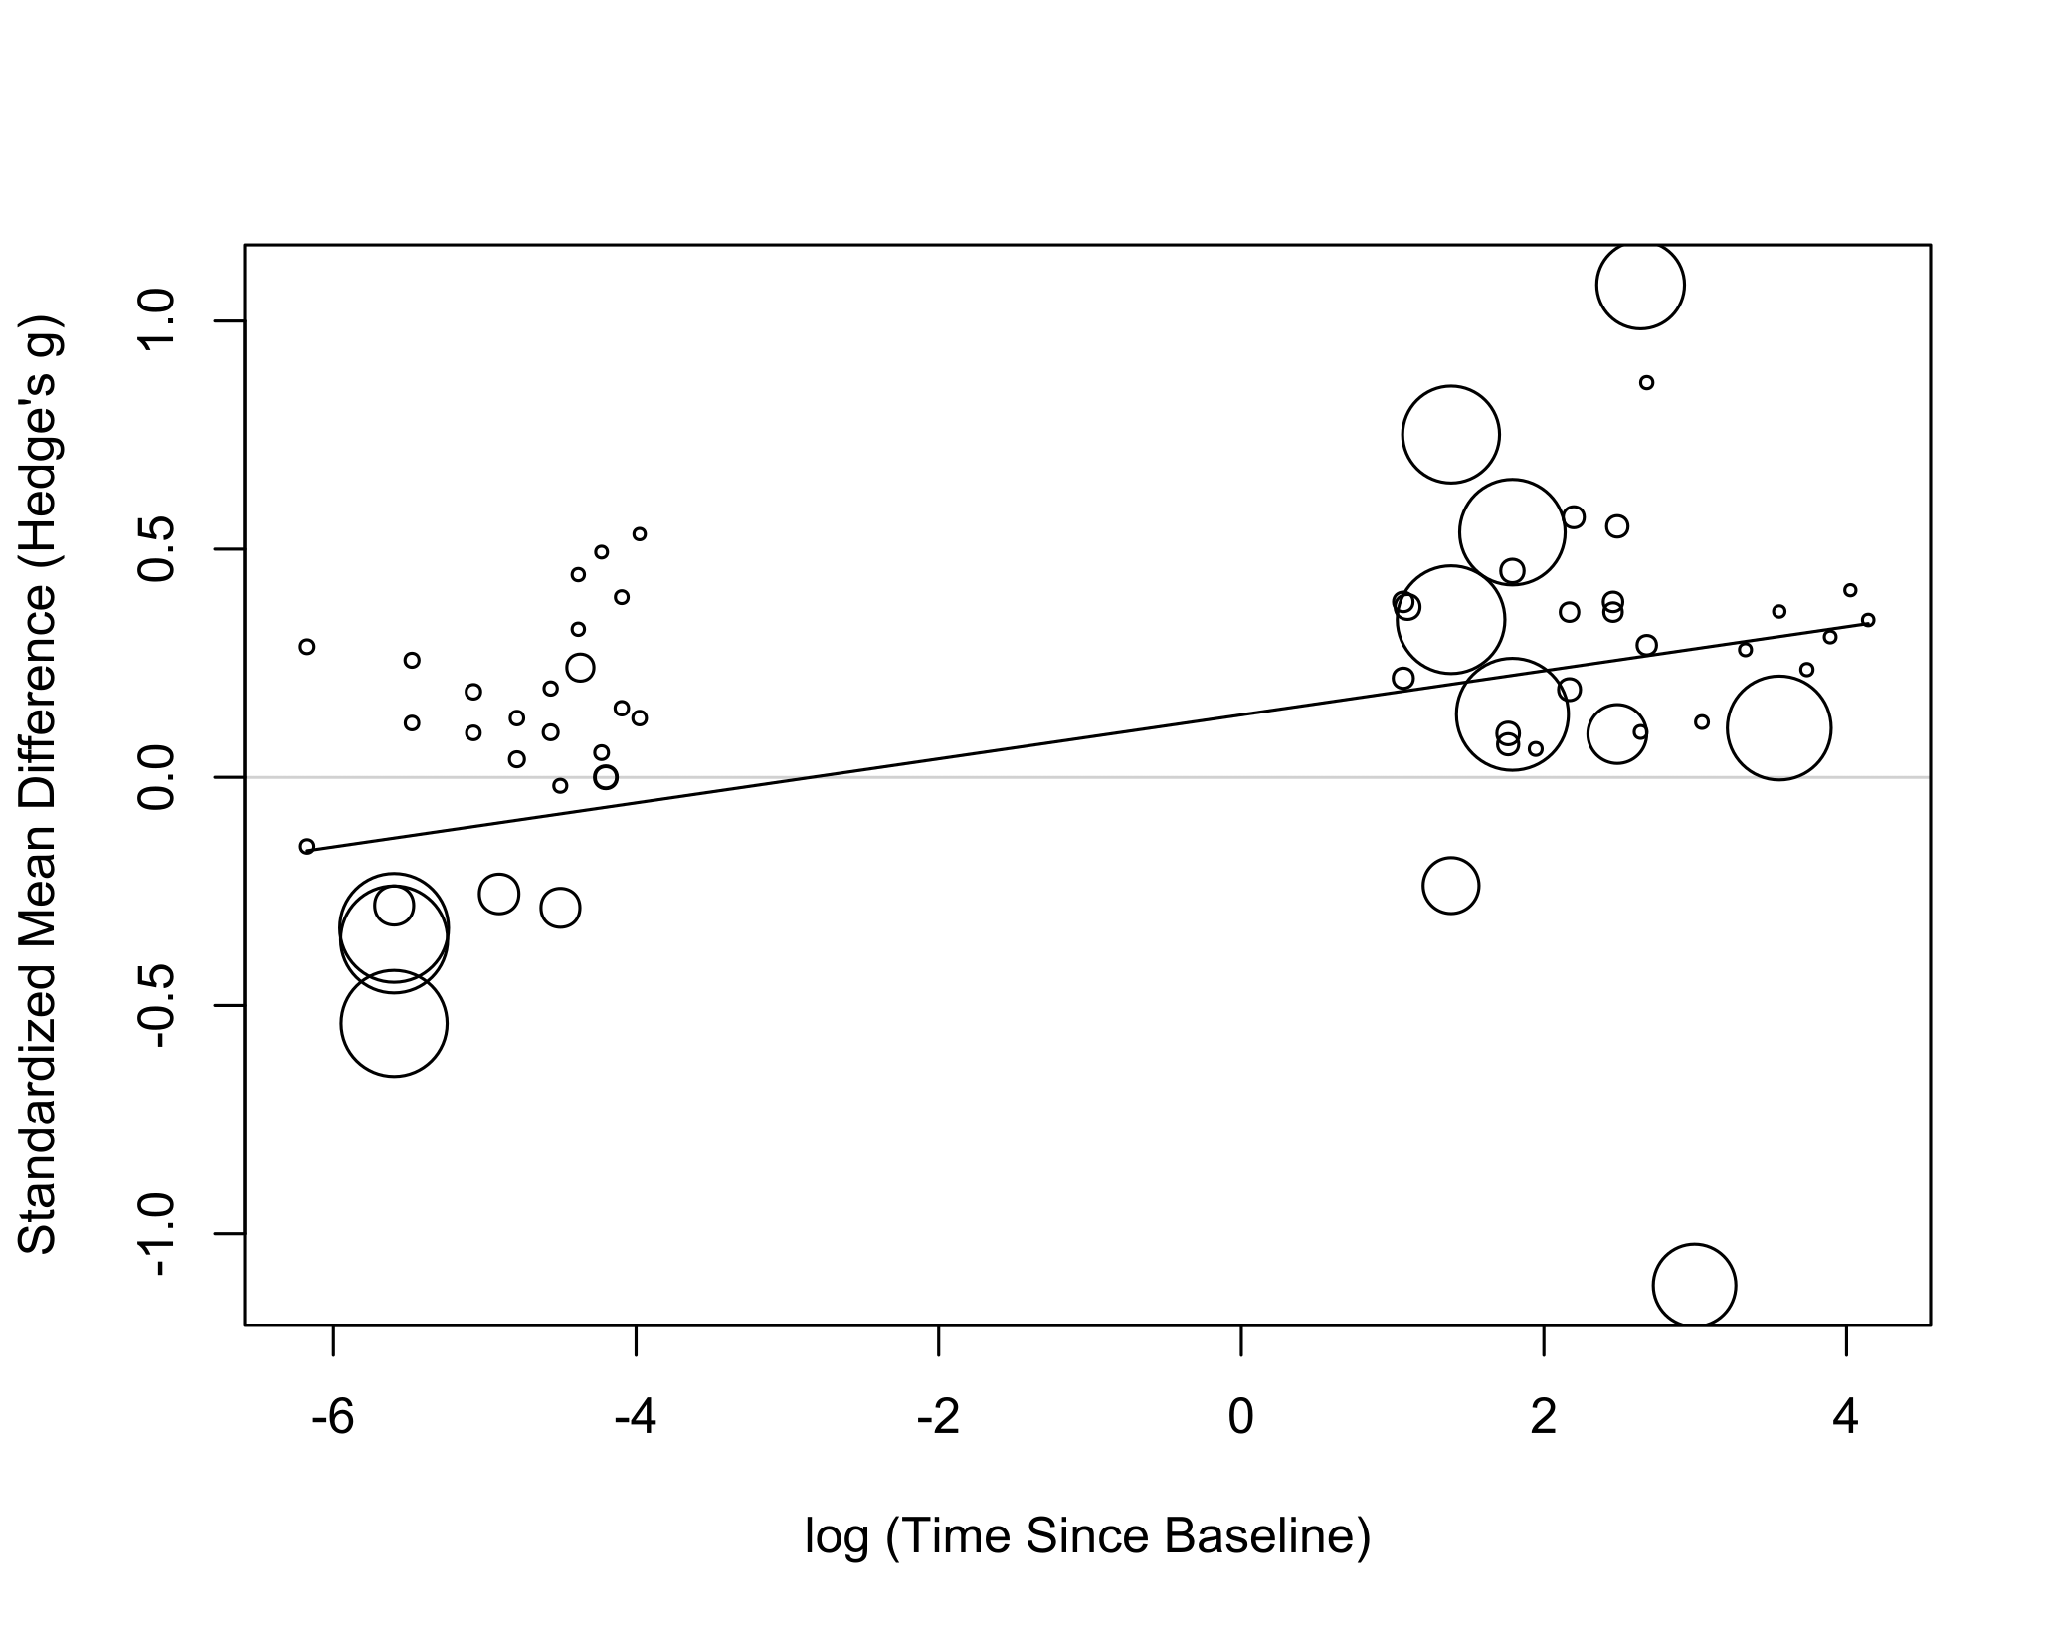

t = 3.9, p = .0003 t =4.7, p <0.0001

### Interaction Between Amount of time and training since the first baseline

## Model Results:  
##   
## estimate se tval df pval   
## intrcpt -0.2658 0.2807 -0.9469 56 0.3477  
## log.train_amount_since_first 0.0979 0.0635 1.5423 56 0.1286  
## log.time_since_first 0.0013 0.0411 0.0323 56 0.9744   
## time X amount of training 0.0071 0.0087 0.8198 56 0.4158

# Meta Regression: Total Training Duration

## Total Training since First Training Trial

There was a significant relationship between log(total training duration) and SMD from first training trial to last training trial.

## R^2 (amount of heterogeneity accounted for): 13.19%  
##   
  
## Model Results:  
   
## estimate se tval df pval

intrcpt -0.0115 0.1470 -0.0784 32 0.9380

training.dur.min.log 0.0845 0.0340 2.4873 32 0.0183*

## Total Training since Baseline

There was no significant relationship between training duration and SMD from baseline to post training rest.

## R^2 (amount of heterogeneity accounted for): 0.00%

## Model Results:  
##   
## estimate se tval df pval

## intrcpt 0.6081 0.6530 0.9312 16 0.3656

training.dur.min.log -0.0637 0.1268 -0.5025 16 0.6222

# Egger’s Test

There was significant evidence of publication bias

## Eggers' test of the intercept   
## =============================   
##   
## intercept 95% CI t p  
## 2.527 0.76 - 4.3 2.797 0.0068  
##

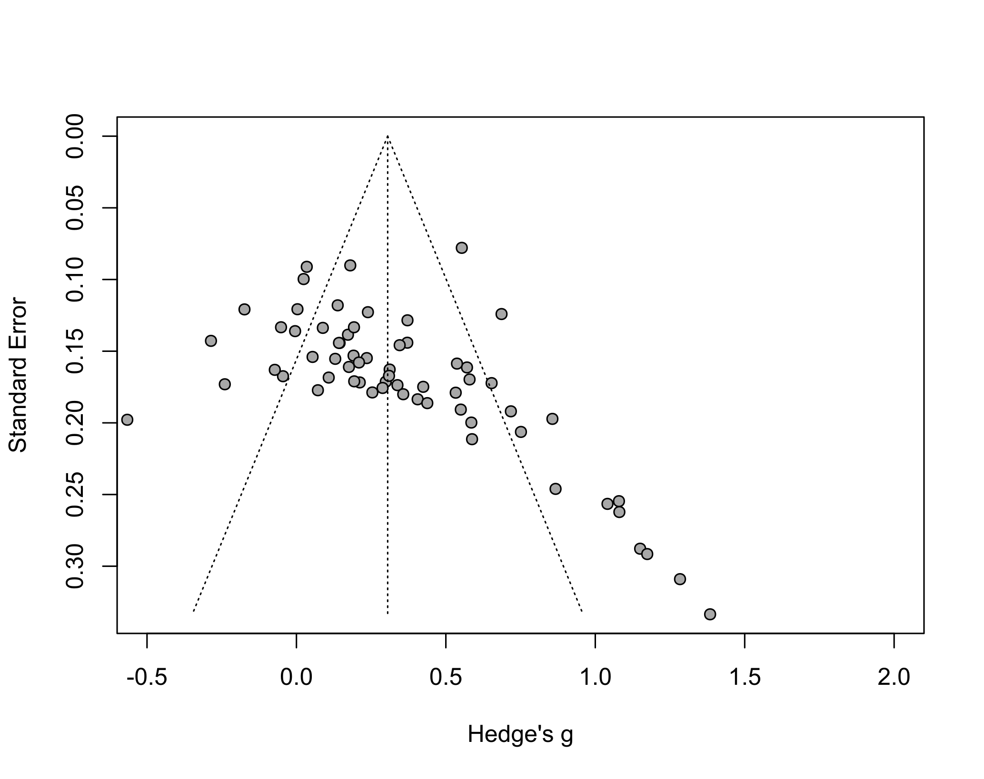

# Quality Assessment

Below is the weighted percentage of papers that met the following quality criteria:

